JQuery Examples

jQuery with CSS:

1. addClass()
2. removeClass()
3. toggleClass()
4. css()

1. addClass()

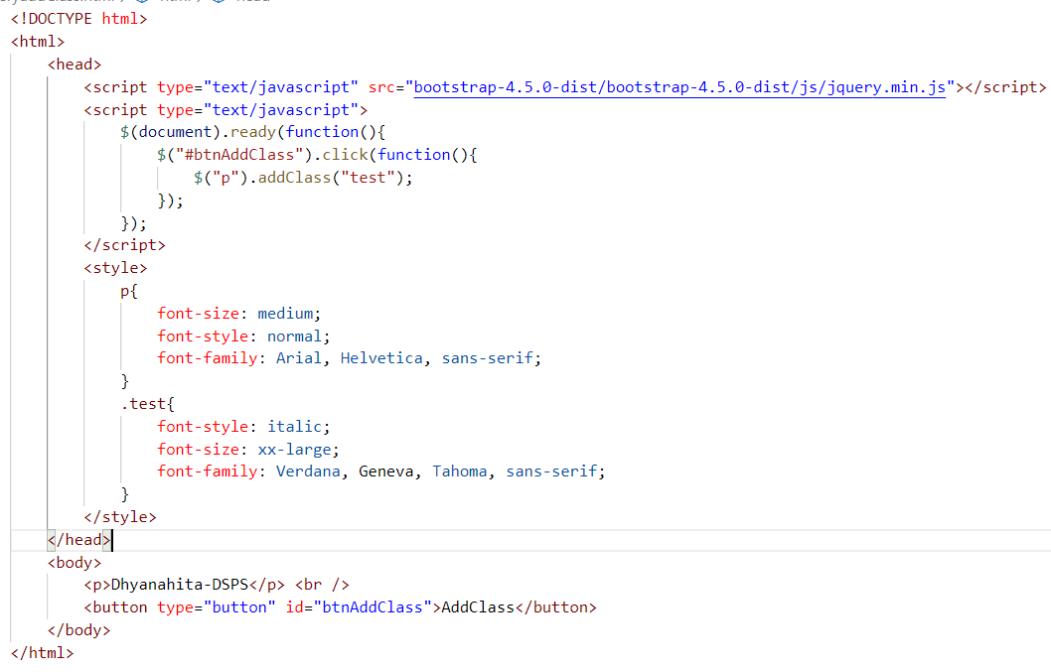

2. removeClass()

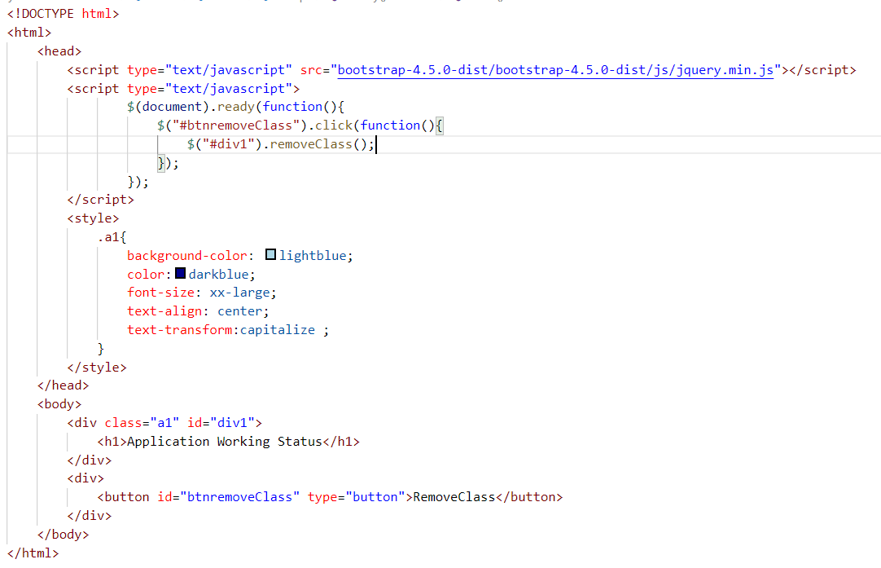

3. toggleClass

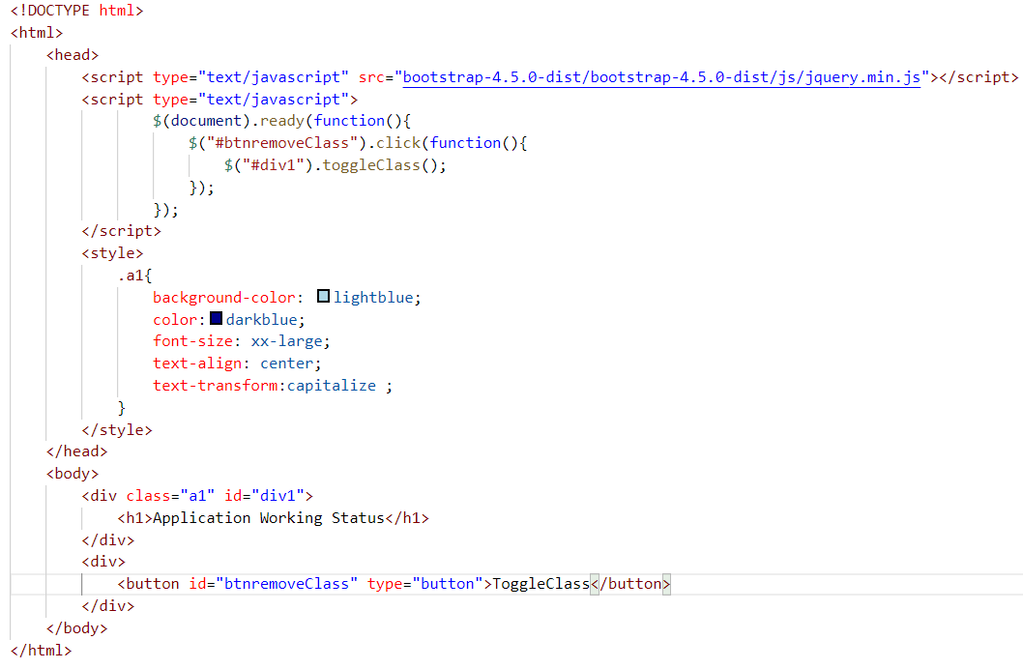

4. css()

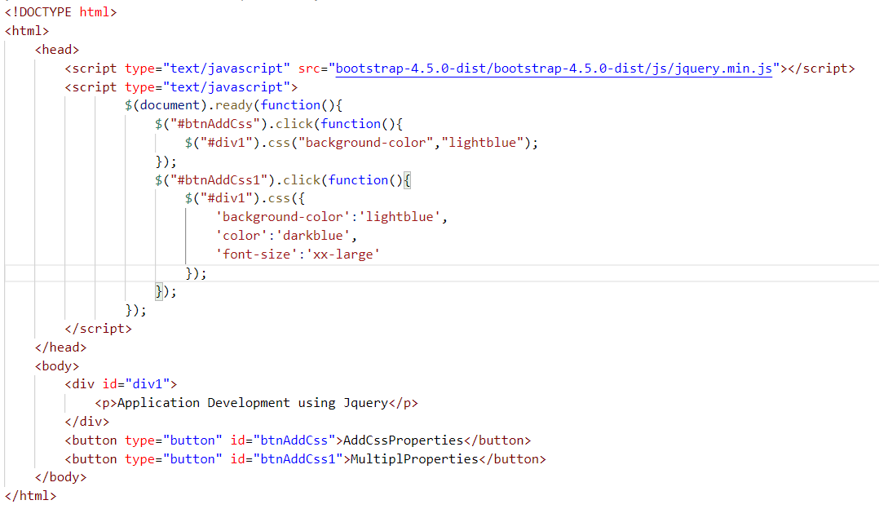

Jquery Validations

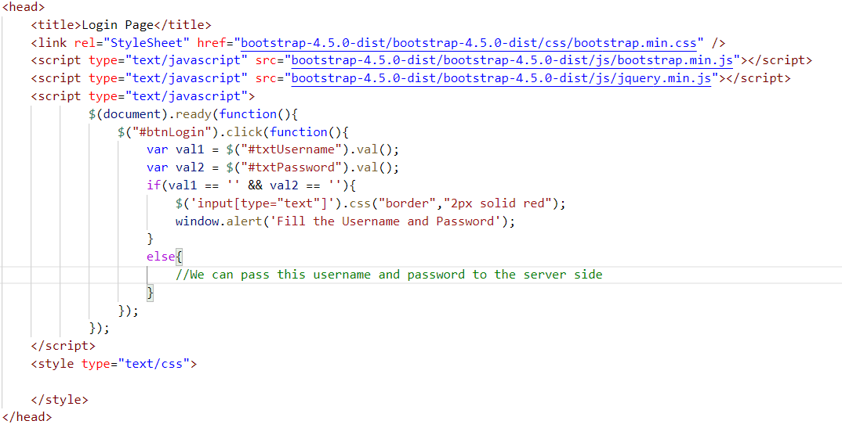

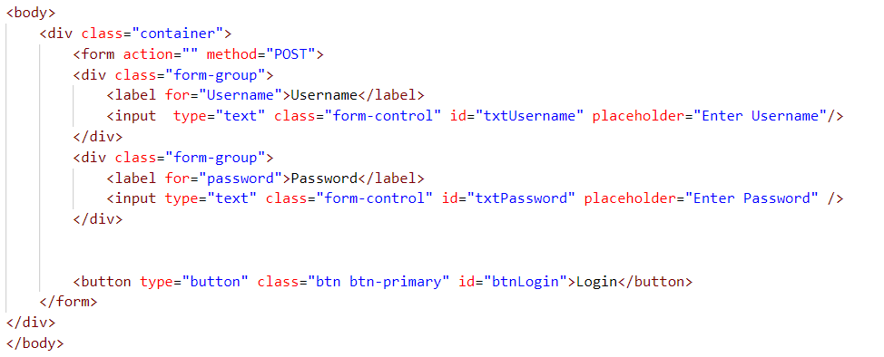

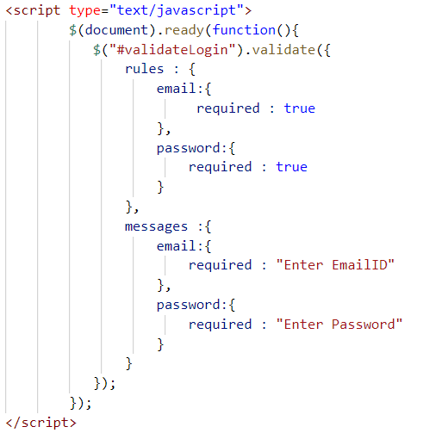

Task: Validate the Username and Password which is minimum length of 6 characters and maximum length of 12 characters

Task : Validate the Registration Page with basic input fields like Username, EmailID, Mobile Numbers, Password, Address.